Cloud Computing Experiment – 1

Question:
Create a simple cloud software application and provide it as a service using any Cloud Service Provider to demonstrate Software as a Service (SaaS).
Answer:
AIM: To create and deploy a simple cloud software application using Zoho Creator and provide it as a Software as a Service (SaaS) application.
PROCEDURE:
Go to the Zoho Creator website and log in with your Zoho account.
- Click Create from Scratch to start a new app.
- Select Web Application and type a name for your app.
- Make a simple form with fields like Name, Email, and Description.
- Save the form and turn on cloud access so people can use it online.
- Copy and share the app link with others so they can open and use it.
- Your software is ready

IMPLEMENTATION:
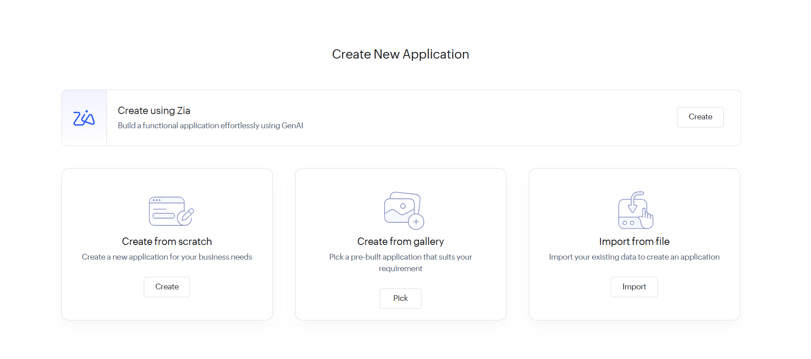
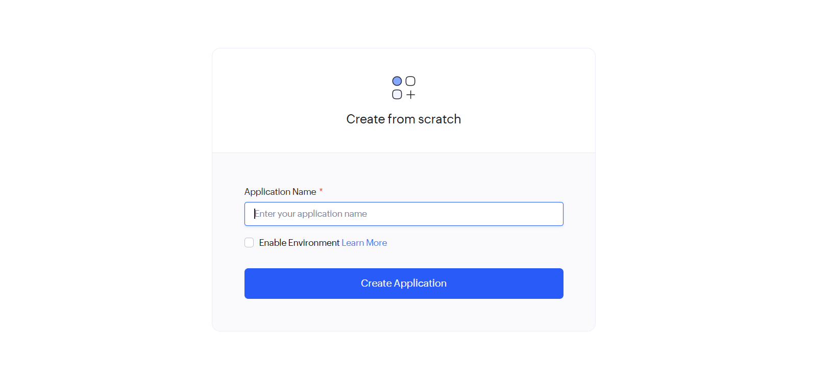
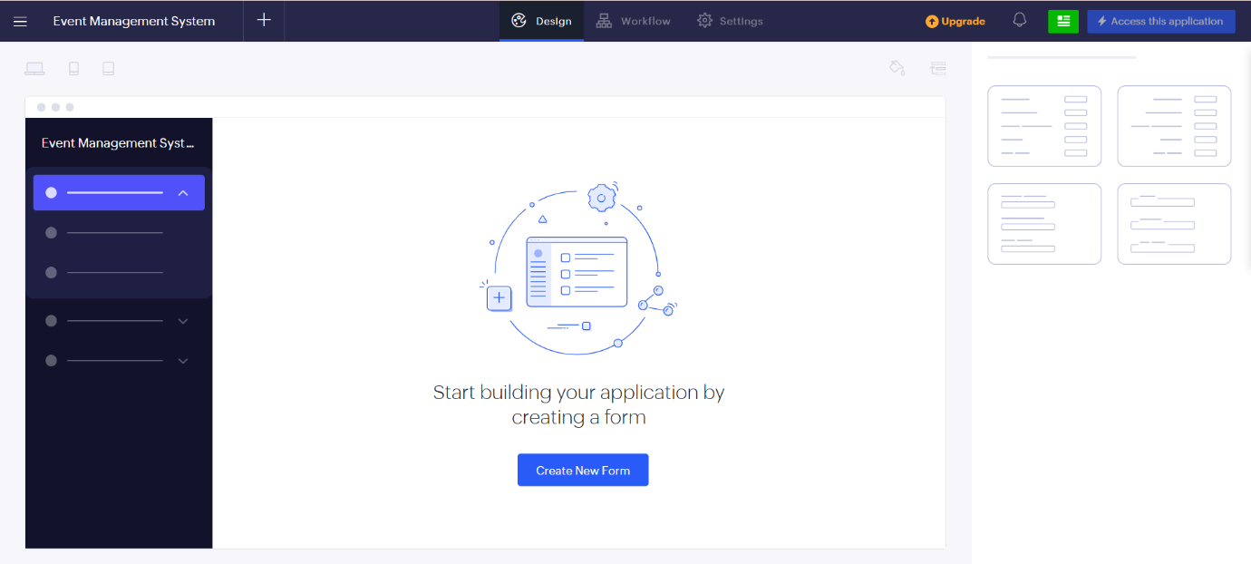
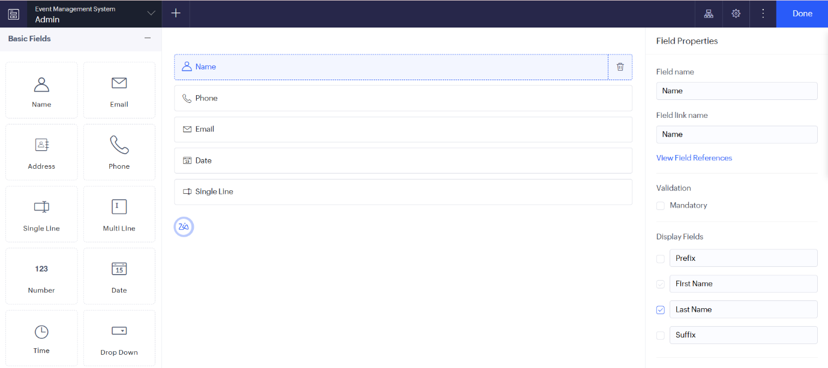

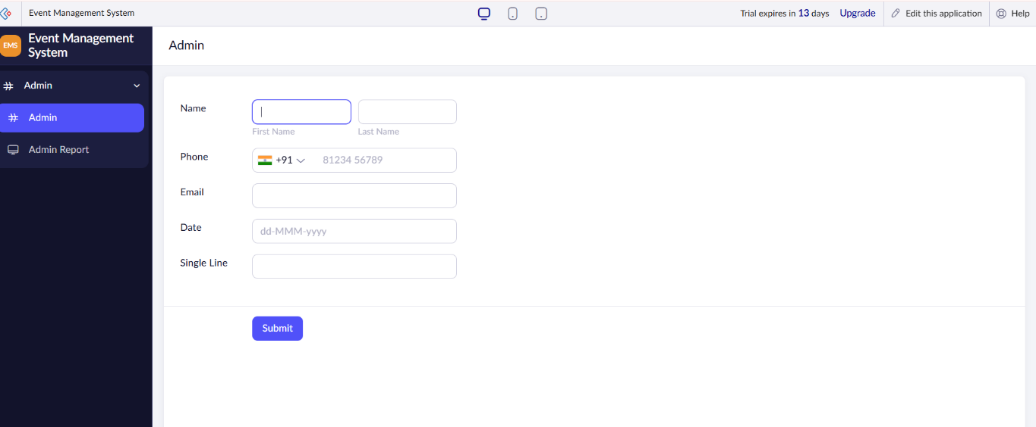

RESULT: A simple software app has been made on the cloud. It is given as a SaaS app, which means people can open and use it through the internet.

